**Getting Started with minikube.**

1. minikube start --driver=docker

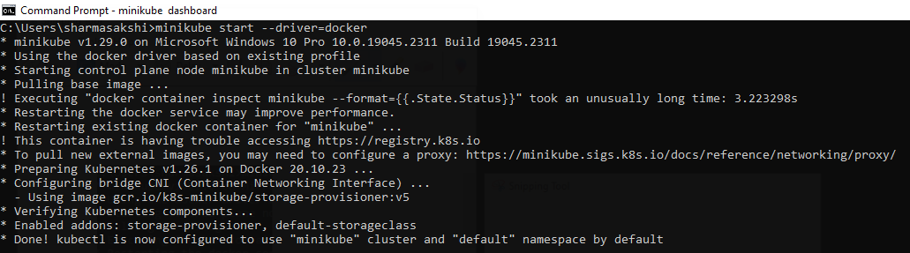

1. Interact with your cluster, 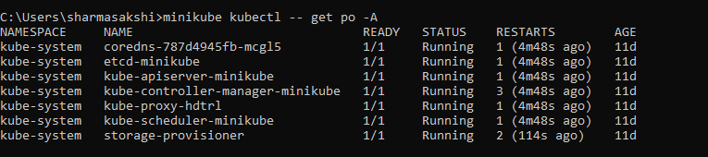
2. minikube dashboard 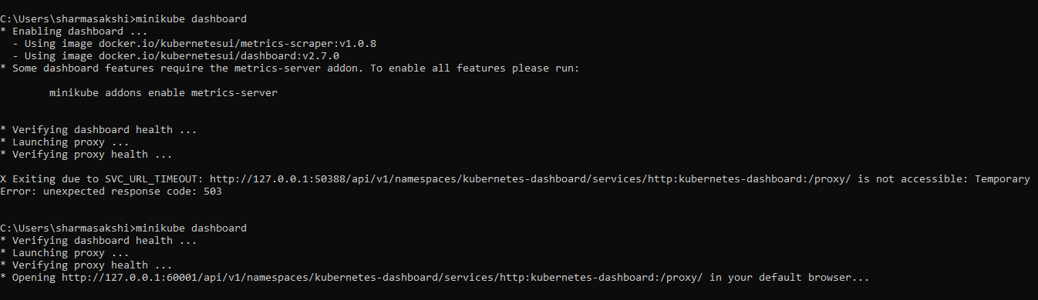
3. Opening Dashboard

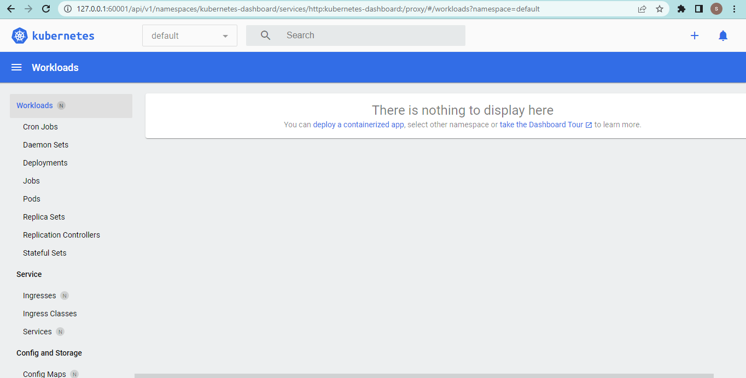

## Create a Deployment

## kubectl create deployment hello-node --image=registry.k8s.io/e2e-test-images/agnhost:2.39 -- /agnhost netexec --http-port=8080

## kubectl get deployments

## kubectl get pods

## 

## 